PRACTICAL QUESTIONS FOR DATA VISUALISATION AND ANALYTICS (CIA1C11)
Practical 6 – Data Preparation and Analytics II (Data Transformation)

Introduction: At the end of EDA, the data analyst will have a pretty good assessment of what needs to be done to improve the data quality. The next step is therefore to execute the data preparation process to make the data more useful and efficient downstream. Generally, these are the things that are involved:
- Data Cleaning – remove errors/anomalies, handle missing values, re-format data type, split or extract substrings, conform data to standardized pattern (lower/upper case)
- Data Transformation – recode/discretize, derive new fields, aggregate, de-duplicate, normalize
- Data Reshaping/Joining – transpose data, join data, concatenate data

Practical 5-6 will cover various aspects of Data Preparation.

Objective: The aim of Practical 6 is to focus on data preparation techniques for data reshaping/joining and data transformation.

Question 1 : To transform data (aggregate)
Question 2 : To transform (aggregate, de-duplicate, re-code), re-shape/join (join data tables)
Question 3 : To analyze the prepared data using visualizations

Dataset: For our task this week, we will make use of a dataset containing purchase records captured by a fictitious retailer.

Ready? Let’s get started!

Question 1 (Sorting, Grouping)
Like the previous practical, the format of the dataset is not immediately usable. Each row of the dataset represents one transaction, which means that a customer who purchased multiple products can appear in multiple rows. The purpose of this question is to transform the data using sorting and aggregating in order to analyse by customers.

In the process of exploring the data, we may be able to discover things such as:

- Who are the top customers in terms of amount spent?
- Who are the top customers in terms of number of products purchased?
- Who are the top Customers in terms of number of distinct products?

- Read Data
Create a new KNIME Workflow, call it “P06”.
We will make use of a dataset on purchase history for customers, load the file Purchase_History.xlsx into your workflow using the Excel Reader node

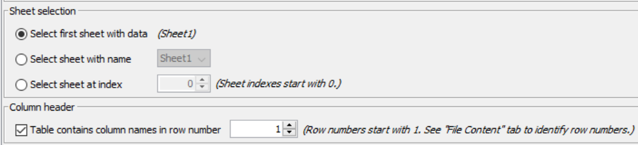
Make sure to Select first sheet with Data (Sheet 1).
Make sure Table contains column name in row number 1 is checked.

Scroll down to the Preview area.
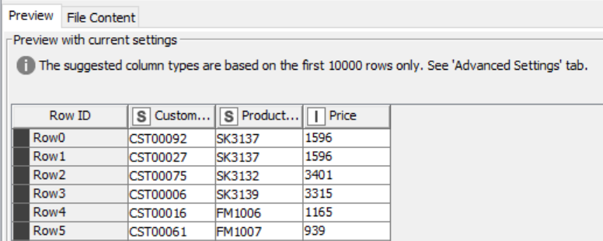

Notice a warning “The suggested column types are based on the first 10000 rows only. See ‘Ádvanced Settings’ tab.” Similar to all other reader nodes, KNIME will read data in each column and ‘guess’ its type (double, string etc.). By default, it will read data from 10000 rows to do this ‘guessing’ but you can configure the number of rows if you wish to.

Click OK and Execute. Verify that you have 1032 rows, 3 columns (excluding Row ID)
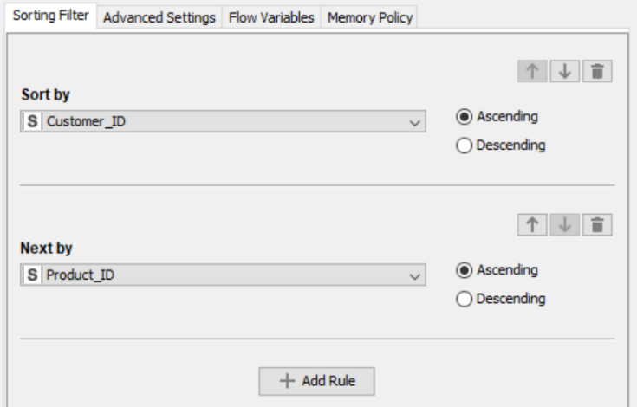
Add a Sorter node downstream.

Configure it as such :
Sort by Customer_ID first
Click +Add Rule
Next by Product_ID.

Execute the Sorter node and view the output. Notice that one customer can purchase multiple products, and one customer can purchase the same product more than one. For example, customer CST00001 bought SK3128 twice.

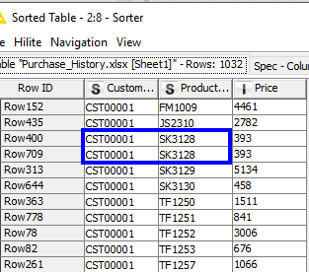

- Transform Data – Aggregation (Sum)
We want to identify our valued customers based on their purchase history. Specifically, we want to find the following:
- Customers who spent the most
- Customers who bought the most number of products
- Customers who bought the most number of distinct products.

First, let’s find customers who have spent the most, based on the purchase history.

Add a GroupBy node downstream from the Excel Reader node. We will modify the name of this node to be “Highest Value”

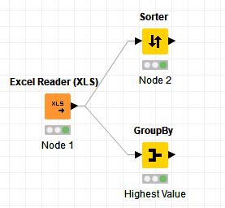

Set Customer_ID to be the Group column.

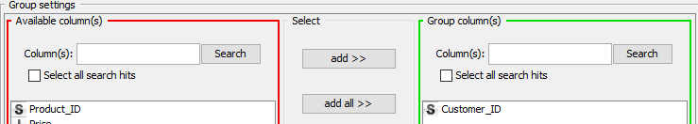

Set Price as the Aggregated column, select Sum as the Aggregation method.
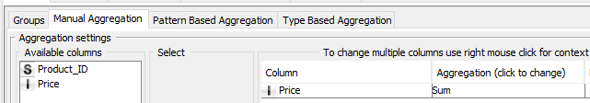

Execute the node, in the output table, sort the newly generated Sum column in descending order. You should be able to identify the customers who spent the most.

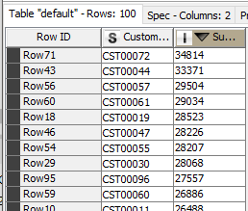

 | Question:  - Who are the top customers in terms of amount spent??
Answer: CST 00072, CST 00044

- Transform Data – Aggregation (Count)
We will now identify customers who have bought the greatest number of products, regardless of price.

Add a new GroupBy node downstream from the Excel Reader node.
We will name this node “Highest Count”.

Use the same setting for the Grouping column, i.e., select Customer_ID.

For the Aggregation column, select Product_ID, for the Aggregation method, select Count.

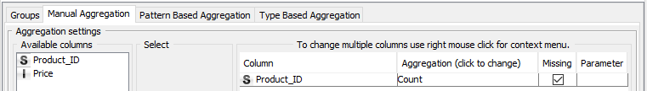

Execute the node, in the output table, sort the newly generated Count column in descending order. You should be able to identify the customers who made the most number of purchase.

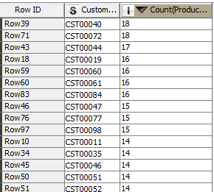

 | Question:  - Who are the top customers in terms of number of products purchased?
Answer:

- Transform Data – Aggregation (Unique Count)
We will now identify customers who have bought the most number of distinct products.

Add a GroupBy node downstream from Excel Reader node.
We will name this node “Highest Distinct Count”.
Your stream should resemble the one shown below.
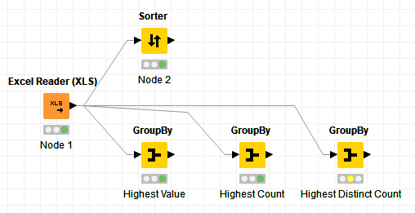

Use the same setting for the Grouping column, i.e., select Customer_ID.
For the Aggregation column, select Product_ID, for the Aggregation method, select Unique Count.
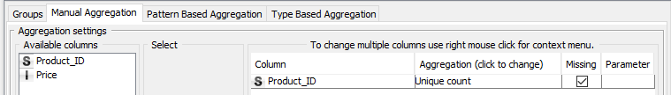

Execute the GroupBy node and sort the newly generated Unique count column in descending order. You will be able to identify the customers who purchase the most number of distinct items.
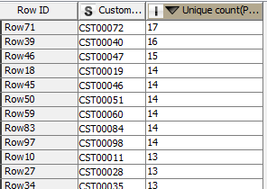

 | Question:  - Who are the top Customers in terms of number of distinct products?
Answer:

Question 2 (Data Aggregating, de-duplication, deriving new fields, joining data)
The purpose of this question is to reshape the data to get the following:
- Create one summary table by customer to capture the products and quantity bought (using data aggregation and de-duplication)
- Create another summary table by product to capture the unit price (using aggregating, de-duplication) and to derive a new field to reflect the product category (using
- Then join the two tables above together.

We will use the resulting data table to do an analysis in Question 3.

- Transform Data – De-duplication (create summary table by Customer ID, Product ID, Quantity)
We will continue from the previous workflow.
We want to transform the purchase history data such that we can capture the quantity bought for each item for each customer.

In other words, we want to produce a table that resemble what is shown below.
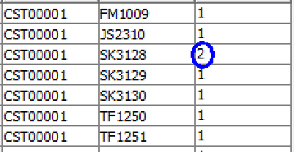

Add a GroupBy node downstream from the Excel Reader node.
Add Customer_ID and Product_ID as the Grouping columns.
Add Price as the Aggregation column, use count as the aggregation function.

Such setting would essentially de-duplicate rows where the Customer_ID and Product_ID has the same value, it will also reduce the Price field into count. The original Price value will be lost in this operation, but we will retrieve it later in another step.

Execute the GroupBy node and verify that you are left with 939 rows.

Since the count of Price is essentially representing the quantity bought, we will add a Column Rename node. Double click on Count*(Price) and rename the aggregate column to be Quantity.
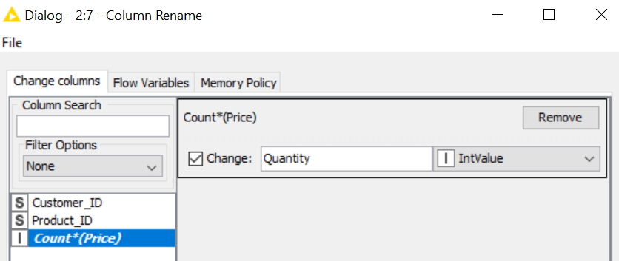

- Transform Data – Recode Product Category
We will now derive the product category and unit price from the products purchased.

Add a Rule Engine node downstream from the Excel Reader node.
Your workflow should resemble the one shown below.

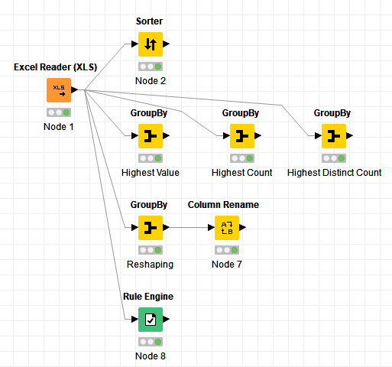

For the purpose of this exercise, we will assume that Product_ID can inform us about the product category.
Product_ID begins with | Product Category
FM | IT & Electronics
SK | Home Appliances
TF | Clothing & Accessories
JS | Health and Nutrition

Add the rules as shown in the screenshot below. Mae sure to add the * (wild card) for each Product ID type.

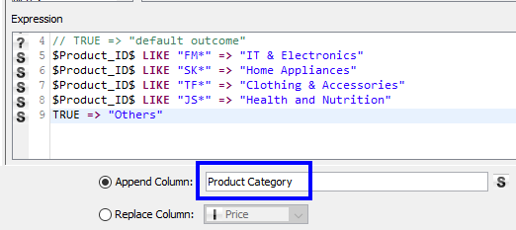

 | Discussion: How do we interpret the rules that we just entered?
Answer:

IF Product_ID begins with “FM” THEN Product_Category is set to be “IT & Electronics”
IF Product_ID begins with “SK” THEN Product_Category is set to be “Home Appliances”
IF Product_ID begins with “TF” THEN Product_Category is set to be “Clothing …”
IF Product_ID begins with “JS” THEN Product_Category is set to be “Heath…”
ELSE (all other cases) Product_Category is set to be “Others”

Note that rules are matched from top to bottom, so order matters.
For example, suppose we have the following rules:
$Age$ < 10 => “Young”
$Age$ = 5 => “Exactly 5”

The row in our dataset with Age = 5 will display the new field as “Young” and not “Exactly 5” since it matches the first rule.

- Transform Data – Aggregation (create summary table by Product Category and Unit Price)
Execute the Rule Engine node and look at the output (right-click > Classified Values)

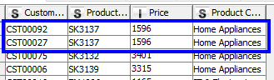

Since our aim is to capture the product category and unit price of individual Product_ID, we need to take two actions on output of the Rule Engine node.
- Drop the Customer_ID field
- Remove duplicated rows (e.g. shown in screenshot above).

We can achieve these actions using one node.
Add a GroupBy node downstream from the Rule Engine node.

Set Product_ID, Price and Product Category to be the Group columns.
Leave the Aggregate column empty.

Execute the GroupBy node.
Verify that you have 50 rows and 3 columns.

Add a Column Rename node downstream from the GroupBy node.
Rename Price to be Unit Price.

- Re-shape/Join Date - Full Outer Join
We will now join the two tables generated in Step 1 and Step 3 to create complete table, readable into Power BI for further analysis.
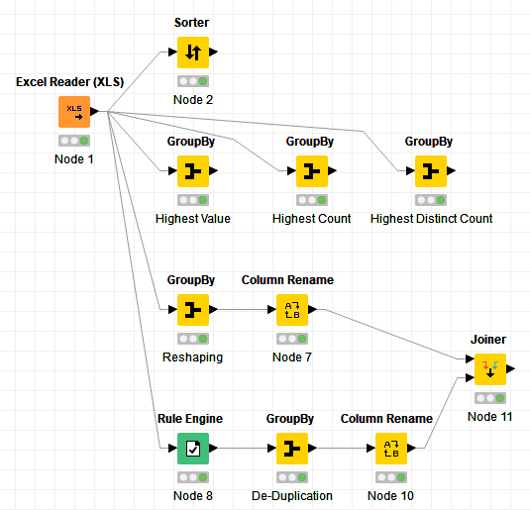
Add a Joiner node, connect it as shown in the diagram below.

Select the Join mode to be Full Outer Join
For Joining Columns, select Product_ID for both the left and right table.
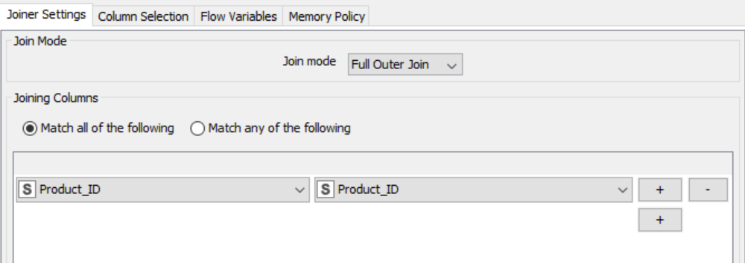

- Write to CSV File
Add a CSV Writer node, connect it downstream from the Joiner node.
Write the table to shopping.csv file, save it to a destination of your choice.
Choose option to Write Column Header. If the file exists, select Overwrite.
We will use this CSV file in the next question.

Question 3 (Visualizing the prepared data)
We will now read the CSV file prepared in Question 2 into Power BI desktop. This will allow us to prepare visualizations (using new column, pie chart, use built-in AI to ask question about data) that can help us answer our questions.
In the process of exploring the data, we may discover more about product category such as:
- How many products are there for each category?
- What is the average amount spent for each product category?

For Mac Users : Use Power BI Service
Power BI Service cannot create new column for “Amount Spent”. To get around this : Open .csv file Add new column called “Amount Spent” in Column F Let Amount Spent = Quantity * Unit Price Set F2 = C2 * D2, then copy formula down the column Save file

Sign in to Power BI Service (in the cloud) Click Get Data Click Get Under File Select Local File Navigate to shopping.csv and select file. You should see the dataset shopping.csv in Power BI Service. Click ⁞ next to shopping.csv Select Create Report. A blank canvas will appear in Report View. You can then continue to step 3.

- Get Data
Launch Power BI desktop and create a new report. Click File > Get Data > Text/CSV and
read the shopping.csv file in the previous question into Power BI. Click Load.

Click on the Data tab, this would give you a view of the loaded data.
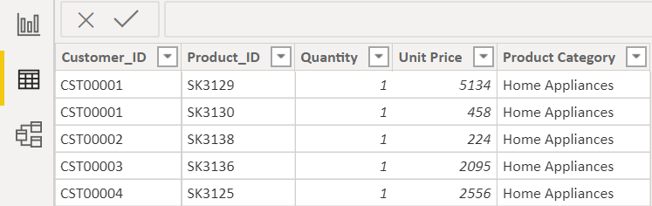

- Create New Column
We will derive a new field called Amount_Spent which is the product of Quantity and Unit Price.
In the panel on the right, right-click on the imported data table (called “shopping”). Select New column .
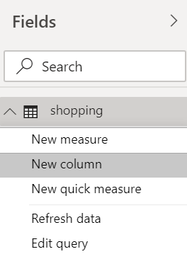

We will set Amount_Spent = Quantity * Unit Price
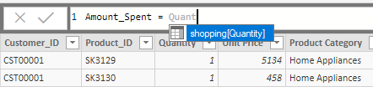
As you type, you will see the auto-completion coming on.
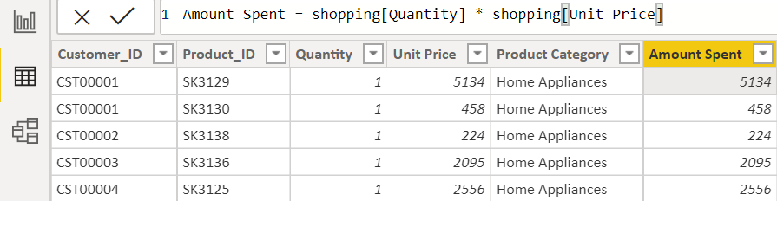
The formula and the newly computed column is shown below. Press Enter and the amount spent for each row will be computed.

- Pie Chart
Go to Report View.
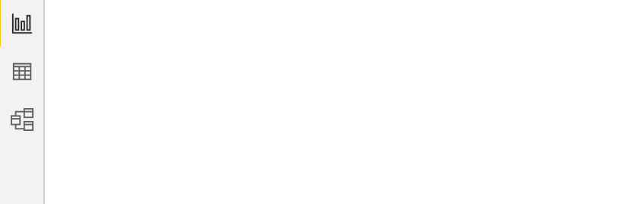

Let’s start by creating a visual showing the breakdown of products by product category.
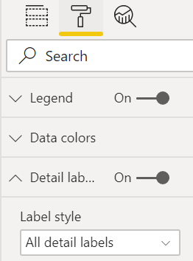
Pie Charts are perfect for visualizing such information. Click on the Pie Chart icon in the visualization pane.
- Select Product Category as the Legend
- Select Count of Product ID as the Value

Navigate to the format tab
- Under Detail label, under Label style, select All detail labels
- Under Text size, change the font size to 12.

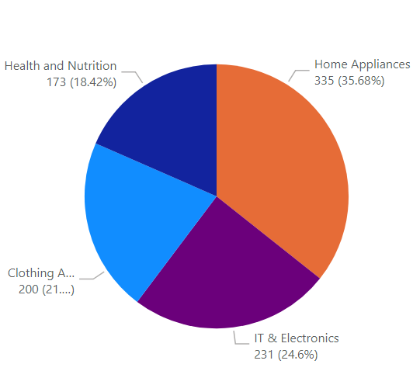

 | Question:  - How many products are there for each category?
Answer:

Best performing – home appliances, most number of produvts

 | Discussion: What is the underlying assumption when we answered part d – how many products are there for each category?
Answer:

Since we are studying the product purchase data, we are assuming that there was at least one transaction for each product. Could there be some products with 0 transaction?

- Use Built-in AI To Ask Question About Data
Next, we will create a visual showing the average spent on purchase for each product category.

We shall use the “Ask a Question about our data” feature. Double-click on an empty area in your report canvas and enter “average amount spent by product category”

This action will produce a bar chart resembling the one shown below. (Format : Data Labels On Increase font size)
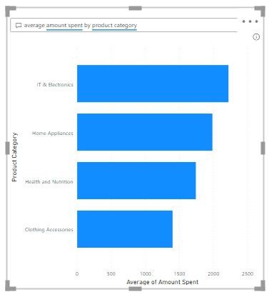

 | Question:  - What is the average amount spent for each product category?
Answer:

- Save your Power BI report.
Question 4 (Practice Question – Will not be covered in class)
- Continuing from Question 3, produce visuals in Power BI for question parts a, b and c. That is, produce visuals to find the following:

- Who are the top customers in terms of amount spent?

- Who are the top customers in terms of number of products purchased?
[Hint: sum the quantity]

- Who are the top Customers in terms of number of distinct products?

Question 5 (Practice Question – Will not be covered in class)
- In Question 3, step 2, we derived a new column called Amount_Spent in Power BI desktop. (Amount_Spent = Quantity * Unit Price)

Load your KNIME workflow for this Practical again, connect a Math Formula node downstream from the Joiner node. Enter the mathematical expression that can allow you to derive the Amount_Spent in KNIME.

– End of Practical 6 –

 | Summary:
In this practical, we explore how we can sort, group and aggregate data to derive insights. We also looked at how we can make use of logical condition (if-then rules) to derive values for new field. We explore how we can join information in disparate table using joins.

In this practical we made use of the following new nodes (not covered in previous practical) in KNIME.
Node |  | Purpose | Remarks
Sorter |  | Sorts the rows according to user-defined criteria | Nil
Column Rename |  | This node allows you to rename column | It also allows you to change the column type if necessary
Rule Engine |  | This node takes a list of user-defined rules and tries to match them to each row in the input table. If a rule matches, its outcome value is added into a new column. | Order matters. The first matching rule in order of definition determines the outcome.
Joiner |  | This node joins two separate tables based on your defined joining mode. | The join mode matters, so does that orientation of the table. The table connected to the top input port is the left table.  You will learn more about joins in DBAV

